**IBM-Technion Airborne camera project, for detection of movements in recorded video**

Selected article for starting implementation is “***fast video object segmentation technique***”:

<http://calvin.inf.ed.ac.uk/wp-content/uploads/Publications/papazoglouICCV2013-camera-ready.pdf>

our code located in :

<https://github.com/surferran/AirBorneCamera_C_code/>

**detailed algorithm scheme for implementation:**

**optical flow (Dense)**

between subsequent frames

**Section 3.1**

The flow is :

$$flowfield=f_{p}=\left\{f_{x}\left(p\left(x,y\right)\right),f_{y}\left(p\left(x,y\right)\right)\right\}$$

$$magnitude of flow change=μ=❘∇_{x,y}f_{p}❘$$

$$strengh of change={b_{p}}^{m}=1-Ε^{-λ^{m}μ}∈\left[0,1\right]$$

${b_{p}}^{m}\sim 0.5$ is not accurate because we cannot differ the source is true boundary or noise.

$$N-pixel neighbourhood$$

$$f_{p},f_{q}→θ_{p,q}$$

$$α_{pq}=δ{θ_{p,q}}^{2}$$

$$α_{p,N}=\max_{q∈N}\left(α_{pq}\right)$$

$$strengh of direction change of pixel from it^{'}s neighbours= {b_{p}}^{θ}=1-Ε^{-λ^{θ}α_{p,N}}∈\left[0,1\right]$$

The last element is wrong when the flow is slow. Or static. So it’s not reliable.

Total criteria can be :

$b_{p}=\begin{aligned}{b_{p}}^{m} {b_{p}}^{m}>T \\ {b_{p}}^{m}{b_{p}}^{θ} {b_{p}}^{m}≤T\end{aligned}$ while T is 0.5

$$b_{p}=\begin{aligned}b_{p}>0.5→the pixel is part of the motion boundary \\ b_{p}<0.5→the pixel is static, part of background, or inside the object\end{aligned}$$

$b_{p} is a binaric map (1f in the article)$. It includes open boundaries. And errors from wrong optical flow inputs.

----

Part of voting :

More then 4 intersections of rays with motion boundaries curves – the pixel is inside the object.

It uses ‘integral intersections’ based on integral images concept. $(2b in the article)$

4 matrices of $S_{i}(WxH);i=1,2,3,4$

(0,0) pixel (and 0 index rows/columns) are assumed as background. Rays of 0,45,90 deg are starting from there.

Odd number of cross-sections of motion boundaries bt the ray – meaning that the ray origin point is ‘inside’.

X as number of intersections, for pixel p(x,y). and:

$$X_{left}=S\left(x-1,y\right)$$

$$X_{right}=S\left(W,y\right)-S\left(x,y\right)$$

$result of 3.1 section in the article=$ $M^{t}$: inside-outside map, for each time-frame ‘t’.

-----

Calc optical flow – run for all frames of video (option : store as Mat files).

SuperPixels – run for all frames of video

Calc Bpm

Calc BpTheta

Calc Votes

Calc Mt

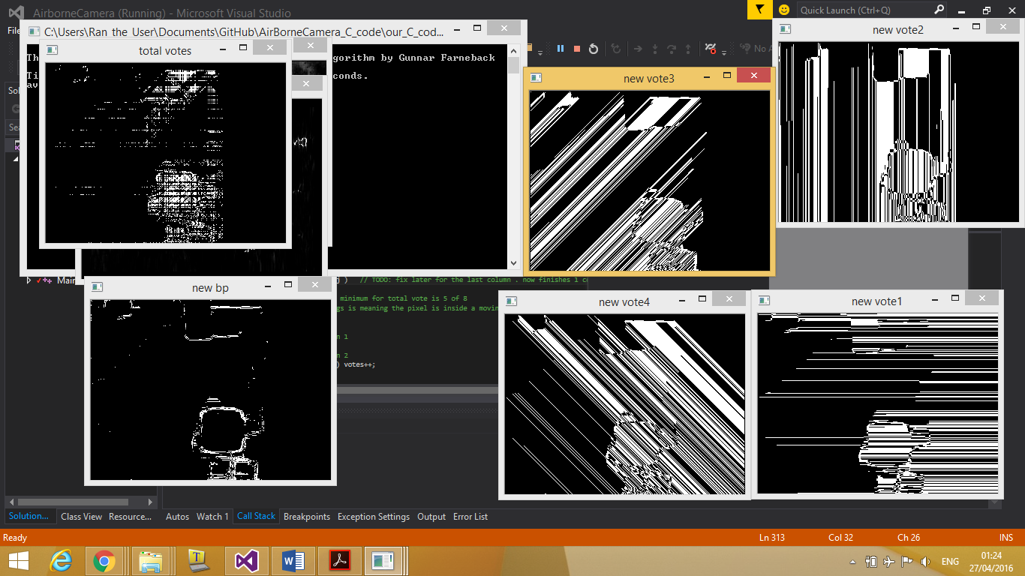

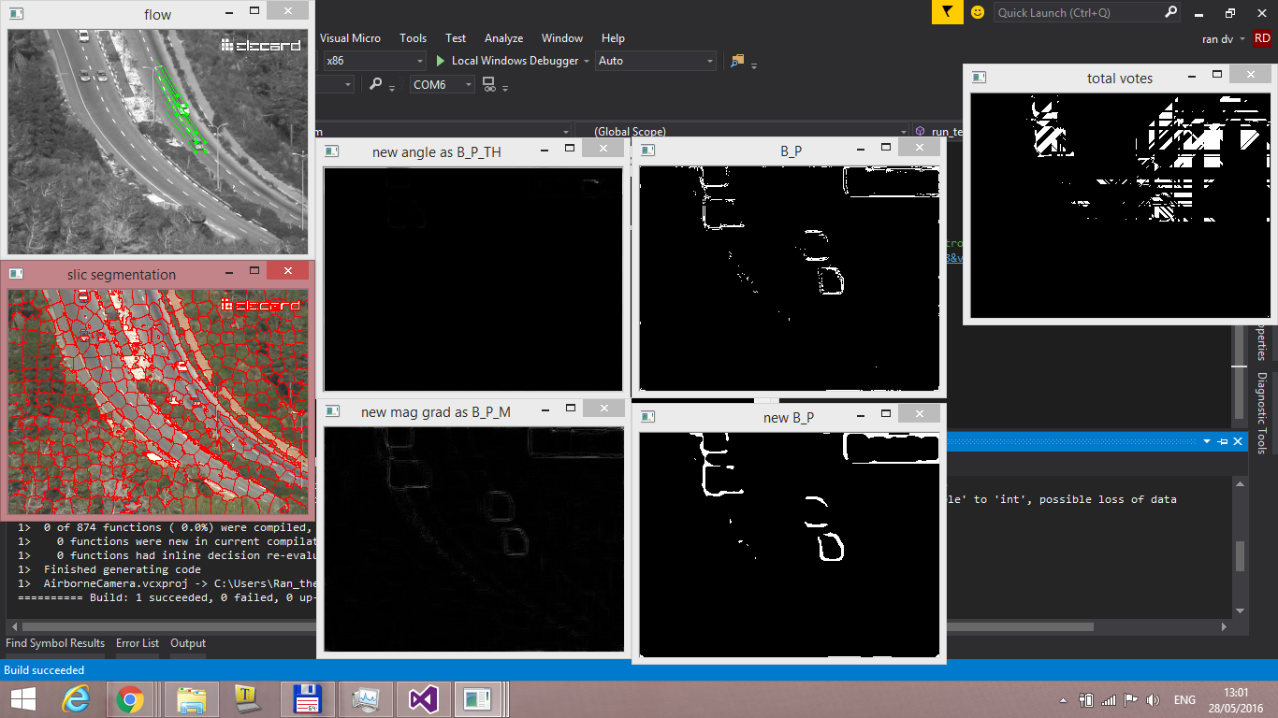

----

Next:

Implement build of cost function matrices.

Potentials matrices:

V,W as spatial and temporal smoothness, across 1 frame, or 2-frames, respectively.